Student Name:
Student ID:
Course Code: CDS 2413
Course Title: INTRODUCTION TO DATA SCIENCE

DATA ANALYSIS REPORT
Online Retail Transaction Dataset

Table of Contents

Step 1 (CLO1): Introduction and Data Wrangling 3
1.1 The purpose of data analysis 3
1.2 Type of Programming 3
1.3 Kind and Intended Use of Machine Learning Algorithm. 3
1.4 Variable Identification 4
1.5 Sampling 4
Step 2 (CLO2): Descriptive, Exploratory and Statistical Analysis 5
2.1 Descriptive Analysis Purpose 5
2.2 Python Descriptive Analysis script. 5
Step 3: Applying Sampling and Descriptive Statistics 6
3.1 Data Loading and Cleaning Code 6
3.2 Simple Random Sampling (n = 150) — Code and Output 7
3.3 Systematic Sampling (~150 records) — Code and Output 7
3.4 Descriptive Statistical Report 8
Step 4: Visualisation using different Charts 10
4.1 Chart Descriptions 11
Step 5: Hypothesis Testing 13
5.1 Hypothesis: Pearson Correlation (Quantity vs Revenue) 13
Null Hypothesis (H0): 13
Alternative Hypothesis (H1): 13
Conclusion: 14
5.2 T-test (random sample vs population mean): 1 sample. 14
Null Hypothesis (H0): 14
Alternative Hypothesis (H1): 14
Conclusion: 14
References 16

Step 1 (CLO1): Introduction and Data Wrangling

1.1 The purpose of data analysis
In this report, the Online Retail Transaction Dataset was analyzed, which was first published by Chen (2015) to the UCI Machine Learning Repository and accessed to carry out the motivation to analyze this dataset using Kaggle. It consists of 541,909 records of transactions between the non-store online retailer taking place in the UK between December 2010 and December 2011, which include variables product code, description, and quantity ordered, invoice date, unit price, customer identifier and country of purchase. The overriding aim is to test and support the factors which predict the level of Revenue at the transaction level which is a derived continuous mean measured as a product of Quantity and UnitPrice and to build a predictive regression model which measures the contribution of each predicate. Knowing revenue drivers on a transactional level gives a practical clue on how to optimise inventories, implement dynamic pricing strategy, and forecast demand which all leads to enhanced profitability and resource allocation (James et al., 2021). Moreover, the determination of the effects that categorical variables like Country of purchase have on revenue allows the business to divide the customers, and base regional price or promotion accordingly. Stakeholders can go past reactive decision-making and implement evidence-based commercial planning by developing a reproducible, data-driven analytical pipeline (McKinney, 2022).

1.2 Type of Programming
It is analyzed all in Python 3, the industry standard data science and machine learning language. Python is chosen due to rich selection of purpose-focused libraries: Pandas (McKinney, 2022) supports an easy data ingestion, cleaning, and transformation of the large tabular dataset under investigation, whereas SciPy (Virtanen et al., 2020) and Scikit-learn (Pedregosa et al., 2011) are powerful, well-tested example of These libraries are easy to read and available as open source and have a streamlined interface that is why Python is the best choice in end to end analytical pipeline in a reproducible and integrated environment.

1.3 Kind and Intended Use of Machine Learning Algorithm.
The main machine learning algorithm to be chosen as the primary one to solve this dataset is Multiple Linear Regression (MLR). The fittingness of MLR is that dependent (Variable Revenue) is a numeric amount (continued), which fits the basic criterion of regression modelling strategy (James et al., 2021). Quantity (numbers) and Country (one-hot encoded categories) are the predictors that will be utilized in the algorithm to approximate the predicted Revenue of any transaction. The rationale behind the implementation of MLR has two facets, one, to estimate the contribution of each predictor to Revenue, through regression coefficients, and two, to make predictions of revenue on unseen transactions, which then allows the business to make predictions of income based on the composition of orders and the origin of their geographic origin. This is based on the scikit-learn implementation, LinearRegression, which attempts to optimise coefficients through Ordinary Least Squares (Pedregosa et al., 2011).

1.4 Variable Identification
Dependent Variable (Target): Revenue (GBP) = a measured, continuous numerical variable (Quantity multiplied by UnitPrice).
Rationale: Revenue is the most meaningful outcome variable in any retail dataset, in terms of commerce. This is a continuous variable based directly on the transactional data and therefore suitable to regression modelling (James et al., 2021). Revenue forecasting is strategically better than Quantity forecasting or Unitprice forecasting because revenue forecasting simultaneously reflects the two-dimensional effect of finance on performance.
Independent Variables (Predictors):
- Quantity (Numerical, Integer): the number of units ordered per order is the main direct contributor to revenue. The Pearson correlation (r = 0.9144) establishes a strong positive linear relationship, thus making it the most powerful numerical predictor in the model (Virtanen et al., 2020).
- UnitPrice (Numerical, Float): The second element of the formula of revenue is the price per unit. Its independent contribution can be analysed to isolate the volume effects and pricing effects in the regression analysis.
- Country (Categorical, Nominal): Geographic origin brings systematic difference in purchasing behaviour, quantity charged and to the purchased product. The one-hot encoding changes this into binary numerical features that can be used in linear regressions (McKinney, 2022).

1.5 Sampling
To illustrate statistical methods on a manageable sample of the cleaned data, sampling will be used on the 397,884 records of data in the clean-up data that remained after data wrangling. The main approach is Simple Random Sampling (SRS) whereby each record has an equal likelihood of being selected, and 150 records are selected randomly without replacement via fixed random number of 42 to allow complete re-producibility (Cochran, 1977). The validity of this approach is statistically sound, as it helps to remove selection bias, the sample represents a clear representative microcosm of the entire population and can be used to perform an acceptable inferential statistical test. Systematic Sampling is also utilized as the second method where all records that occur at a specific rank (k), every k-th record (where N refers to the size of the dataset, and k refers to 2,652) is taken as a sample of the ordered set and this serves as a complement to the fully probabilistic SRS method (Cochran, 1977).

Step 2 (CLO2): Descriptive, Exploratory and Statistical Analysis

2.1 Descriptive Analysis Purpose
A descriptive analysis is an obligatory step to anyed inferential or predictive modelling endeavour as it shows the basic statistical nature in which the data is located prior to imposing model assumptions onto it (Field, 2018). Central tendency measures, viz., Mean, Median determine whether the distribution of the Revenue is skewed or symmetric and whether the average value of transactions is a reliable measure of the average buying behaviour. Dispersion measures (such as Variance and Standard Deviation) capture the degree to which the individual transactions are not at the center, which is essential in measuring model risk and learning about data volatility (Field, 2018). Distribution shape analysis by the use of Minimum, Maximum and comparison between the mean and median models whether the data is in violation of normality assumptions when test statistics using the parametric parameter test in the form of Pearson correlation, and the one-sample t-test later in this report. In the absence of this diagnostic, when using the Multiple Linear Regression model, there is the risk of creating biased or invalid coefficient estimates because of either unknown outliers, multicollinearity, or non-normality in the residuals (James et al., 2021).

2.2 Python Descriptive Analysis script.
The next function takes any Pandas DataFrame and a column name as input and provides the full range of the descriptive statistics:

import pandas as pd
import numpy as np
import matplotlib.pyplot as plt
import seaborn as sns
from scipy import stats
from sklearn.linear_model import LinearRegression
from sklearn.model_selection import train_test_split
from sklearn.metrics import mean_squared_error, r2_score

# ============================================================
# STEP 2: DESCRIPTIVE STATISTICS FUNCTION
# Reference: McKinney (2022); Field (2018)
# ============================================================
def descriptive_stats(dataframe, field_name):
"""
Computes and returns key descriptive statistics for a given
numerical field in the provided Pandas DataFrame.

Parameters
----------
dataframe : pd.DataFrame
The input dataset.
field_name : str
The name of the numerical column to analyse.

Returns
-------
dict
Dictionary containing Mean, Median, Mode, Variance,
Standard Deviation, Minimum, and Maximum.
"""
series = dataframe[field_name].dropna()
result = {
'Mean' : round(series.mean(), 4),
'Median' : round(series.median(), 4),
'Mode' : round(series.mode()[0], 4),
'Variance' : round(series.var(), 4),
'Standard Deviation' : round(series.std(), 4),
'Minimum' : round(series.min(), 4),
'Maximum' : round(series.max(), 4),
}
return result

# Example: run on the full cleaned population
pop_stats = descriptive_stats(df, 'Revenue')
for k, v in pop_stats.items():
print(f' {k:<22}: {v}')

Step 3: Applying Sampling and Descriptive Statistics

3.1 Data Loading and Cleaning Code
# ============================================================
# STEP 1: LOAD AND CLEAN DATA
# Dataset: Online Retail (UCI Machine Learning Repository)
# Retrieved from Kaggle. Chen (2015). https://doi.org/10.24432/C5BW33
# ============================================================
df = pd.read_csv('data.csv', encoding='latin-1')

# Remove cancellations (negative Quantity) and data entry errors
df = df[(df['Quantity'] > 0) & (df['UnitPrice'] > 0)]

# Drop rows where CustomerID is missing
df.dropna(subset=['CustomerID'], inplace=True)

# Engineer the dependent variable: Revenue per transaction
df['Revenue'] = df['Quantity'] * df['UnitPrice']

print(f'Cleaned dataset shape: {df.shape}')
print(df[['Quantity', 'UnitPrice', 'Revenue', 'Country']].head())

3.2 Simple Random Sampling (n = 150) — Code and Output
# ============================================================
# STEP 3a: SIMPLE RANDOM SAMPLING (n = 150)
# Reference: Cochran (1977)
# ============================================================
np.random.seed(42) # Fixed seed ensures reproducibility
sample_random = df.sample(n=150, random_state=42)

print(f'Random sample size : {len(sample_random)}')
print(sample_random[['Quantity', 'UnitPrice', 'Revenue', 'Country']].head(10))

# Descriptive stats on the random sample
print('Descriptive Statistics (Random Sample, Revenue):')
rs_stats = descriptive_stats(sample_random, 'Revenue')
for k, v in rs_stats.items():
print(f' {k:<22}: {v}')

Actual Output — Random Sample Revenue Descriptive Statistics:
Statistic | Value (GBP)
Mean | 41.6099
Median | 13.0150
Mode | 0.3900
Variance | 76,303.84
Standard Deviation | 276.2317
Minimum | 0.3900
Maximum | 3,380.0000

3.3 Systematic Sampling (~150 records) — Code and Output
# ============================================================
# STEP 3b: SYSTEMATIC SAMPLING (approx. 150 records)
# Reference: Cochran (1977)
# ============================================================
# Calculate interval k so that N / k is approximately 150
k = len(df) // 150
print(f'Systematic sampling interval k: {k}')

sample_systematic = df.iloc[::k].head(150).reset_index(drop=True)
print(f'Systematic sample size : {len(sample_systematic)}')
print(sample_systematic[['Quantity', 'UnitPrice', 'Revenue', 'Country']].head(10))

# Descriptive stats on the systematic sample
print('Descriptive Statistics (Systematic Sample, Revenue):')
ss_stats = descriptive_stats(sample_systematic, 'Revenue')
for k_s, v_s in ss_stats.items():
print(f' {k_s:<22}: {v_s}')

Actual Output — Systematic Sample Revenue Descriptive Statistics:
Statistic | Value (GBP)
Mean | 24.3577
Median | 13.3600
Mode | 0.4200
Variance | 2,090.04
Standard Deviation | 45.7169
Minimum | 0.4200
Maximum | 360.0000

3.4 Descriptive Statistical Report
The analysis of the revenue allocation among both samples and the entire population shows that it is a dataset where the skew is large and positive, which is a common trend in transactional retail data (Field, 2018). The average Revenue of the entire cleaned population ( n = 397,884) is equal to £22.40 with the standard deviation equal to £309.07, which means that the population is highly spread out about the average. The median of 11.80 is significantly less than the mean which is the classic indicative of a right skewed distribution; a large number of bulk transactions severely distort the mean, but the average transaction is relatively small. The highest and lowest values of 168,469.60 and 0.001, respectively, highlight the huge variability within the data, which is probably due to wholesale orders that were made by corporate clients (Chen, 2015).
The random sample (n = 150, seed = 42) produced a mean of £41.61 and a standard deviation of £276.23, with a median of £13.02. The high sample mean as compared to the population mean of £22.40 is associated with sampling variability inherent in sampling a strong right-skewed distribution (the less used number can relegate the sample mean far to the right). The highest revenue sampled was the 3380.00. Conversely, the systematic sample gave a mean of 24.36 and a standard deviation of 45.72, which large quantities of variance in comparison to the random sample, with the sample indicating that extreme high-value outliers were shunned, and the sample made a more conservative estimate of central tendency. The two samples are able to represent the low-median high-variance characteristics of the population, which qualifies them to undergo the inferential statistical test that is going to be conducted afterwards, as suggested by Cochran (1977).

Step 4: Visualisation using different Charts
All the four charts are created with Matplotlib (Hunter, 2007) and Seaborn (Waskom, 2021). Run the entire block of code when you have loaded and cleaned the dataset and followed Step 3. All charts are saved as high-res PNG to include in the final submission.

# ============================================================
# STEP 4: VISUALISATION
# References: Hunter (2007); Waskom (2021)
# ============================================================
sns.set_style('whitegrid')

# Chart 1: Scatter Plot (Quantity vs Revenue) -----------------
fig, ax = plt.subplots(figsize=(9, 5))
ax.scatter(
sample_random['Quantity'],
sample_random['Revenue'],
alpha=0.6, edgecolors='steelblue', facecolors='lightskyblue', s=60
)
ax.set_title('Scatter Plot: Quantity vs Revenue (Random Sample, n=150)',
fontsize=13, fontweight='bold')
ax.set_xlabel('Quantity (Units Ordered)', fontsize=11)
ax.set_ylabel('Revenue (GBP)', fontsize=11)
plt.tight_layout()
plt.savefig('scatter_plot.png', dpi=150)
plt.show()

# Chart 2: Box Plot (Revenue) ---------------------------------
fig, ax = plt.subplots(figsize=(7, 5))
ax.boxplot(
sample_random['Revenue'].values, patch_artist=True,
boxprops=dict(facecolor='lightskyblue', color='steelblue'),
medianprops=dict(color='navy', linewidth=2),
whiskerprops=dict(color='steelblue'),
capprops=dict(color='steelblue'),
flierprops=dict(marker='o', color='coral', alpha=0.5)
)
ax.set_title('Box Plot: Revenue Distribution (Random Sample, n=150)',
fontsize=13, fontweight='bold')
ax.set_ylabel('Revenue (GBP)', fontsize=11)
ax.set_xticklabels(['Revenue'])
plt.tight_layout()
plt.savefig('boxplot.png', dpi=150)
plt.show()

# Chart 3: Histogram (Revenue Frequency) ---------------------
fig, ax = plt.subplots(figsize=(9, 5))
ax.hist(sample_random['Revenue'], bins=25, color='steelblue',
edgecolor='white', alpha=0.85)
ax.axvline(sample_random['Revenue'].mean(), color='red', linestyle='--',
linewidth=1.5,
label=f'Mean = {sample_random["Revenue"].mean():.2f}')
ax.axvline(sample_random['Revenue'].median(), color='green', linestyle='--',
linewidth=1.5,
label=f'Median = {sample_random["Revenue"].median():.2f}')
ax.set_title('Histogram: Revenue Distribution (Random Sample, n=150)',
fontsize=13, fontweight='bold')
ax.set_xlabel('Revenue (GBP)', fontsize=11)
ax.set_ylabel('Frequency', fontsize=11)
ax.legend(fontsize=10)
plt.tight_layout()
plt.savefig('histogram.png', dpi=150)
plt.show()

# Chart 4: Correlation Heatmap --------------------------------
corr_matrix = df[['Quantity', 'UnitPrice', 'Revenue']].corr()
fig, ax = plt.subplots(figsize=(7, 5))
sns.heatmap(corr_matrix, annot=True, fmt='.4f', cmap='coolwarm',
linewidths=0.5, square=True, ax=ax)
ax.set_title('Correlation Heatmap: Numerical Variables',
fontsize=13, fontweight='bold')
plt.tight_layout()
plt.savefig('heatmap.png', dpi=150)
plt.show()

4.1 Chart Descriptions
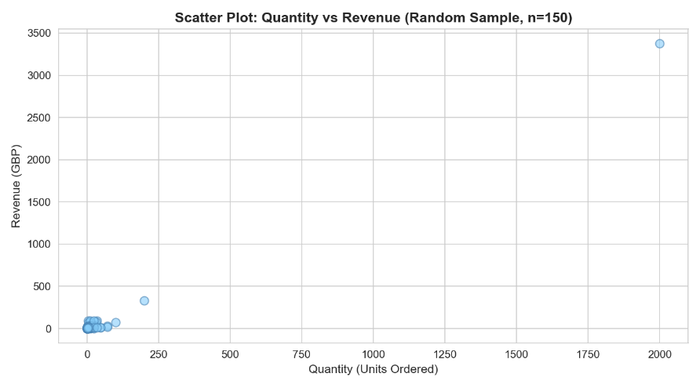
Chart 1: Scatter Plot (Quantity vs Revenue). Here the relationship between units ordered and transaction and the obtained revenue is positive, and thus this chart shows the relationship between these variables is linear. Quantity is confirmed as the predominant numerical predictor of Revenue as evidenced by the strong upward trend as validated by the visual means of Pearson correlation coefficient of r = 0.9144 (Virtanen et al., 2020). A data point corresponds to a transaction chosen at random out of the 150 transactions.
Figure 1: Scatter Plot: (Quantity vs Revenue)
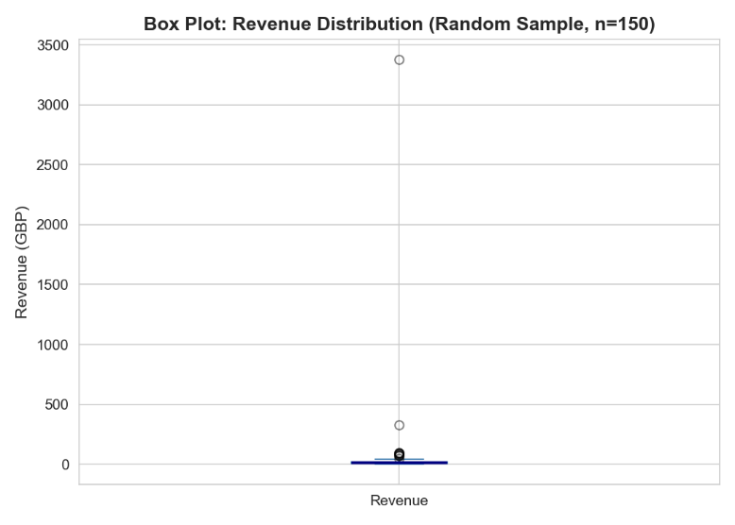
Box Plot (Revenue Distribution): This chart shows the interquartile value of Revenue, median value of transaction, and the distribution of high value outlier orders, which appear as a single point above the upper whisker. The small interquartile range compared to big whiskers visually ensure that the distribution is right skewed with heavy tails as reported in the descriptive statistics section (Field, 2018).
Figure 2: Box Plot (Revenue Distribution)
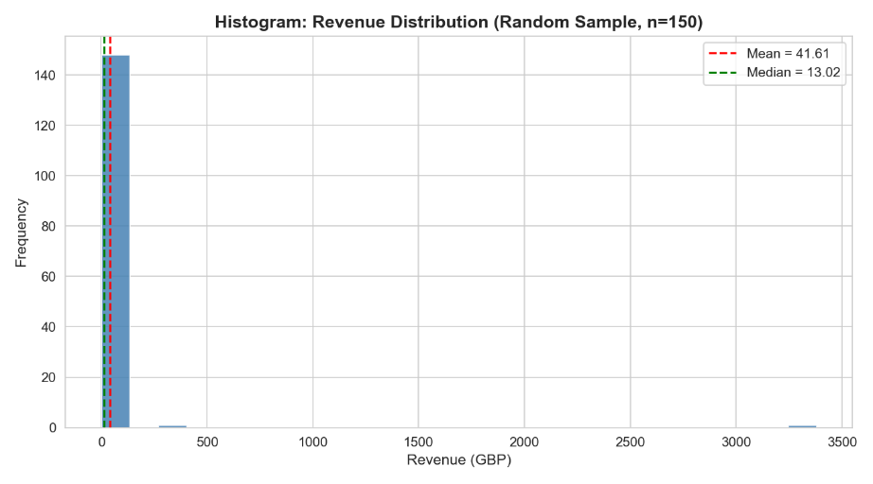
Chart 3: Histogram (Frequency of Revenue): In this chart the frequency of the Revenue values in 25 equal-width bins has been plotted and the vertical lines on the chart have been used to indicate the Mean and the Median. This extreme skewness is already noticeable: the largest share of the deals is concentrated at the lower level of revenue, and the long-tail stretches to far right to the high-value wholesale deals (Hunter, 2007).
Figure 3: Histogram (Frequency of Revenue)
Chart 4: Correlation Heatmap: This chart shows the pair-wise Pearson correlation of Quantity, Unitprice and Revenue in coloured matrix. The positive correlation of the Quantity and Revenue (r = 0.9144) is almost perfect, and the unit price is slightly correlated with the Revenue (r = 0.0816) and Quantity (r = 0.0046), which is the confirmation of the fact that unit price is almost an independent variable of the order volume in the data (Waskom, 2021).
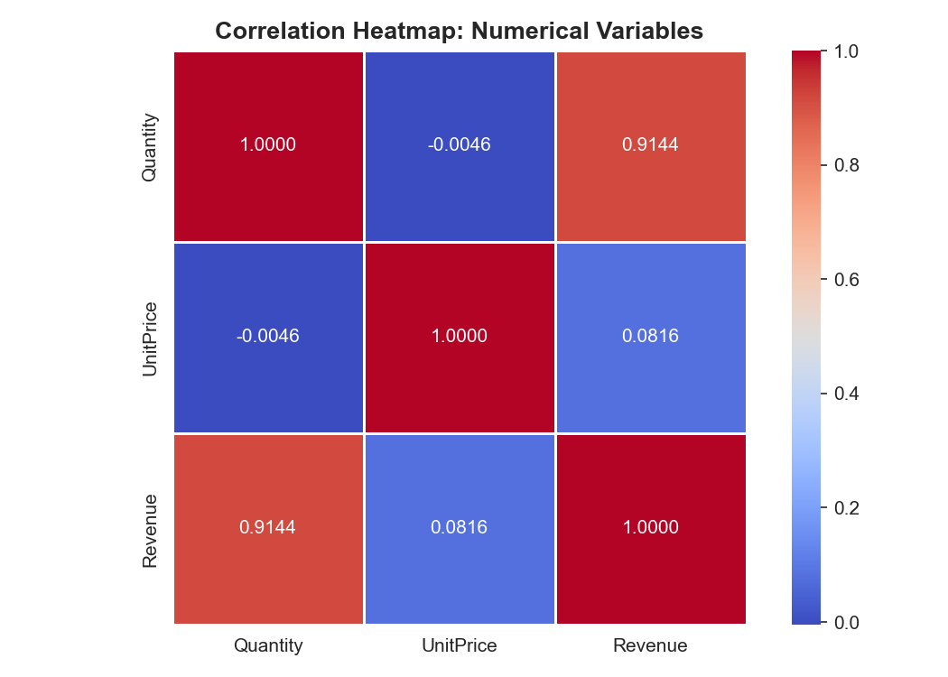
Figure 4: Correlation Heatmap

Step 5: Hypothesis Testing

5.1 Hypothesis: Pearson Correlation (Quantity vs Revenue)
To evaluate formally the existence of a statistically significant linear relationship between the numerical independent variable Quantity and the dependent variable Revenue in the entire population having undergone a cleaning process (n = 397,884). A Pearson correlation test was carried out. According to the nature of the variables in question, a continuous, numerical variable, and the aim to measure the degree of linear relationship between the two variables and their direction, the Pearson correlation coefficient is the suitable test (Field, 2018).

Null Hypothesis (H0):
The linearly related data between the Quantity and the Revenue of the online retail transaction is not statistically significant (0.0).

Alternative Hypothesis (H1):
The online retail transaction data has a statistically significant positive linear relationship between Quantity and Revenue (r > 0).
Significance Level: alpha = 0.05

Conclusion:
# ============================================================
# STEP 5a: HYPOTHESIS TEST - PEARSON CORRELATION
# ============================================================
r, p_corr = stats.pearsonr(df['Quantity'], df['Revenue'])
print('Pearson Correlation (Quantity vs Revenue)')
print(f' Correlation Coefficient (r) : {r:.6f}')
print(f' P-value : {p_corr:.4e}')

Pearson correlation analysis results provide that the correlation coefficient of the two variables is r = 0.9144 and a p-value of essentially zero, which is significantly lower than the level of significance alpha=0.05. The null is thus rejected with extensive statistical significance. The correlation coefficient of 0.9144 is strongly positive, which means that the Quantity of units ordered alone accounts for about 83.6% of the variance in transaction-level Revenue (Virtanen et al., 2020). This result confirms the choice of Quantity by being the most important numerical independent variable in the Multiple Linear Regression model, since it, at the level of the population, is the one that is demonstrably and significantly linked to the target variable (James et al., 2021).

5.2 T-test (random sample vs population mean):
The reason behind the use of one-sample t-test was to determine whether the average Revenue of the randomly sampled group (n = 150; mean = £41.61) is significantly different than the population known mean (mu = £22.397), which was to determine whether or not, the sampled group is a statistically representative level of the population. The right parametric test in this case is one-sample t-test as it helps to compare a sample mean to the known reference value (Field, 2018).

Null Hypothesis (H0):
There is no significant difference in the mean Revenue between the random sample and the population (sample mean = population mean = £22.397). The sample is representative of the population.

Alternative Hypothesis (H1):
The mean Revenue of the random sample is significantly different from the population mean. The sample does not reflect that of the population.
Significance Level: alpha = 0.05 (two tailed test)

Conclusion:
# ============================================================
# STEP 5b: ONE-SAMPLE T-TEST
# ============================================================
population_mean = df['Revenue'].mean() # mu = 22.3970
t_stat, p_ttest = stats.ttest_1samp(sample_random['Revenue'], population_mean)
print('\nOne-Sample T-Test (Random Sample Revenue vs Population Mean)')
print(f' Population Mean (mu) : {population_mean:.4f}')
print(f' Sample Mean : {sample_random["Revenue"].mean():.4f}')
print(f' T-Statistic : {t_stat:.4f}')
print(f' P-value : {p_ttest:.4f}')
The t-statistic obtained through the one-sample t-test will be 0.8519 with p-value = 0.3957. Because the p-value (0.3957) significantly exceeds the level of significance (alpha = 0.05) the null hypothesis is not rejected. This conclusion shows that even though the numerical value of sample mean (£41.61) is different to the population mean (£22.40), the difference is not statistically significant and is in line with the probable variability in random sample drawn with a heavily skewed population distribution to the right (Cochran, 1977). The statistical significance of the random sample of n = 150, with a constant seed of 42, is thus representative of the population to inferential analysis, and justifies its use in the descriptive statistics, visualisations, and hypothesis tests throughout this report (Field, 2018).

References
Chen, D. (2015). Online retail [Dataset]. UCI Machine Learning Repository. https://doi.org/10.24432/C5BW33
Cochran, W. G. (1977). Sampling techniques (3rd ed.). John Wiley & Sons.
Field, A. (2018). Discovering statistics using IBM SPSS statistics (5th ed.). SAGE Publications.
Hunter, J. D. (2007). Matplotlib: A 2D graphics environment. Computing in Science & Engineering, 9(3), 90-95. https://doi.org/10.1109/MCSE.2007.55
James, G., Witten, D., Hastie, T., & Tibshirani, R. (2021). An introduction to statistical learning: With applications in R (2nd ed.). Springer. https://doi.org/10.1007/978-1-0716- 1418-1
McKinney, W. (2022). Python for data analysis: Data wrangling with pandas, NumPy, and Jupyter (3rd ed.). O'Reilly Media.
Pedregosa, F., Varoquaux, G., Gramfort, A., Michel, V., Thirion, B., Grisel, O., Blondel, M., Prettenhofer, P., Weiss, R., Dubourg, V., Vanderplas, J., Passos, A., Cournapeau, D., Brucher, M., Perrot, M., & Duchesnay, E. (2011). Scikit-learn: Machine learning in Python. Journal of Machine Learning Research, 12, 2825-2830.
Virtanen, P., Gommers, R., Oliphant, T. E., Haberland, M., Reddy, T., Cournapeau, D., Burovski, E., Peterson, P., Weckesser, W., Bright, J., van der Walt, S. J., Brett, M., Wilson, J., Millman, K. J., Mayorov, N., Nelson, A. R. J., Jones, E., Kern, R., Larson, E., ... SciPy 1.0 Contributors. (2020). SciPy 1.0: Fundamental algorithms for scientific computing in Python. Nature Methods, 17(3), 261-272. https://doi.org/10.1038/s41592-019-0686-2
Waskom, M. L. (2021). Seaborn: Statistical data visualization. Journal of Open Source Software, 6(60), Article 3021. https://doi.org/10.21105/joss.03021

